


860-571-7500 | ctunitedway.org

Reminder:
Please download a copy of this email template to your computer before customizing it with your organization’s information.

YOUTH BEHAVIORAL HEALTH CRISIS CONTINUUM

Email Template

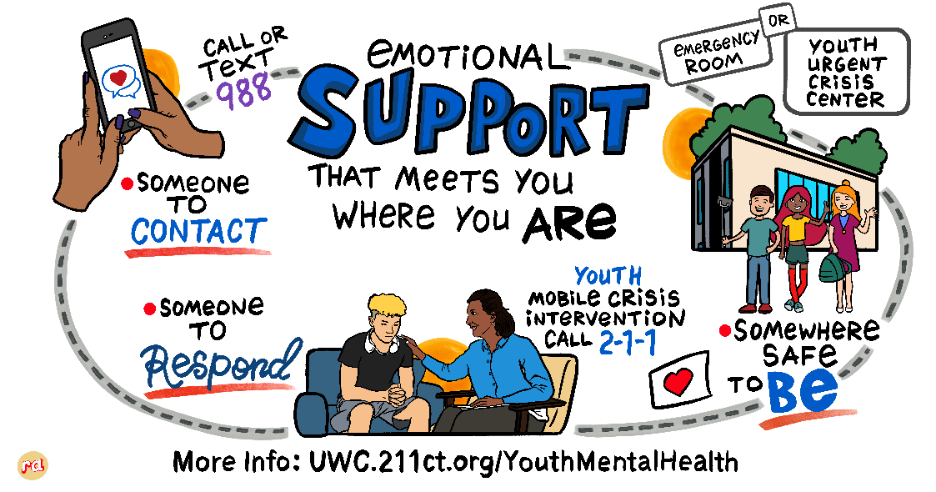

Subject: NEW TOOLKIT: Youth Behavioral Health Crisis Continuum

Dear Partners,
Do you find that your (partners, clients, families) are not fully aware of all the services available to them in the youth crisis continuum? Do they understand the differences between them?

We’re pleased to share a new toolkit of resources that was developed in partnership with the Tow Youth Justice Institute, the State of Connecticut’s Behavioral Health Advocate, Connecticut Department of Children and Families, Youth Mobile Crisis Intervention, Youth Urgent Crisis Centers and United Way of Connecticut.

You might notice that the toolkit messaging is based on SAMHSA’s crisis response framework: Someone to Contact, Someone to Respond and A Safe Place for Help.

We encourage you to deploy and share the assets in this toolkit so that everyone knows and understands that they are not alone and help is available 24/7/365.

Please feel free to reach out with any questions.

Name
Title, Organization

