


860-571-7500 | ctunitedway.org

YOUTH BEHAVIORAL HEALTH CRISIS CONTINUUM

Toolkit of Marketing Materials

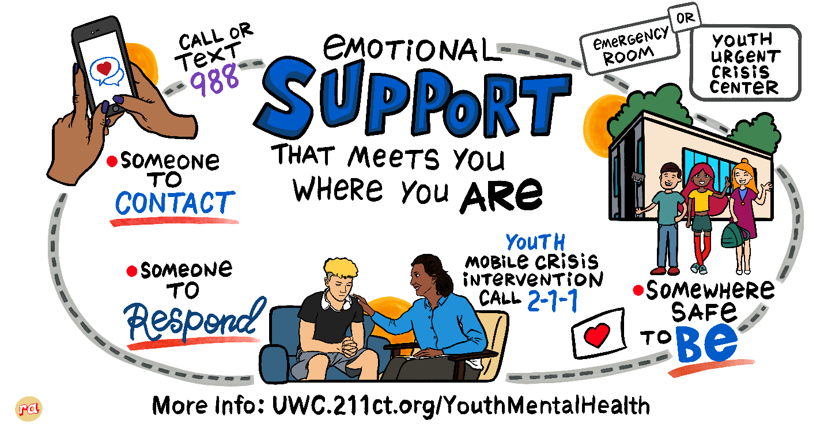

Working in collaboration with the Tow Youth Justice Institute, the State of Connecticut’s Behavioral Health Advocate, Connecticut Department of Children and Families, Youth Mobile Crisis Intervention and Youth Urgent Crisis Centers, United Way of Connecticut has created a Youth Behavioral Health Crisis Continuum Toolkit for Connecticut to use agency wide. The messaging in this toolkit is based on SAMHSA’s crisis response framework: Someone to Contact, Someone to Respond and A Safe Place for Help.
This toolkit will create statewide consistency in messaging and marketing as you update your website information, email templates and create social media posts. By sharing this message together in one voice, we can bring greater visibility, awareness and understanding about the many entry points for youth to receive mental health support.

Stakeholder Outreach
- Website Content

Click HERE to download a copy of the new website content.
This template can be customized with your organization’s logo.

- Email Template

Click HERE to download a copy of the email template.
The email template makes it easier for you to reach out to your donors, corporate partners, Board and other stakeholders to message the Youth Behavioral Health Crisis Continuum.

- Flyer

Click HERE to download a copy of the flyer..

Social Media

Social Media Posts/Graphics

Click HERE to download a copy of the social media post templates.
The document includes posts that can be used on the major social media platforms, including Facebook, Instagram, LinkedIn, and X.
Alt text has been provided for every graphic. Please be sure to include it as you’re queueing up your graphics on each platform.

Questions?
Email Carin Buckman, Director of Communications, United Way of Connecticut, at Carin.Buckman@ctunitedway.org..

